Noakhali Science and Technology University

Department of Information and Communication Engineering

**DIGITAL IMAGE**

**PROCESSING**

**LAB MANUAL 2**

Digital Image Processing Fundamentals

(Using MATLAB)

Prepared By: Md. Sabbir Ejaz

Lecturer, Dept. of ICE

Noakhali Science and Technology University

Department of Information and Communication Engineering

**Lab Objectives:**

This objective of this lab is to understand

1. How to read, display and write an image in Matlab.
2. How to access Image Pixels in Matlab.
3. Mirror, Flipped and Negative Image generation.

**Reading an Image:**

To import an image from any supported graphics image file format, in any of the supported bit depths, use the imread function.

**Syntax:**

A = imread(‘filename.fmt’);

**Description:**

A = imread(‘filename.fmt’) reads a grayscale or color image from the file specified by the string filename, where the string fmt specifies the format of the file. If the file is not in the current directory or in a directory in the MATLAB path, specify the full pathname of the location on your system.

**Display an Image:**

To display image, use the imshow function.

**Syntax:**

imshow(A)

**Description:**

imshow(A) displays the image stored in array A.

**Title an Image:**

To add a title of an image, use the title function.

**Syntax:**

title(‘text’)

**Description:**

title(‘text’) displays the image title top of the image. The title will be the given text.

**Writing Image Data:**

Write image to graphics file, use imwrite function

**Syntax:**

imwrite(A,‘filename.fmt’)

**Example:**

a=imread('pout.tif');

imwrite(a,'b.bmp');

imshow('b.bmp')% imshow is used to display image

title(‘child image’);

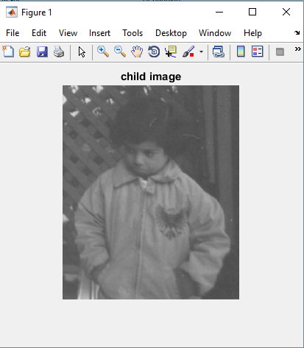

**Writing Image to Disk**

**Get No. of Rows and Columns of an Image:**

Function **size** gives the rows and columns dimension of image

[r,c]=size(a)

r =

291

c =

240

**Accessing the Pixel Data:**

There is a one-to-one correspondence between pixel coordinates and the coordinates MATLAB® uses for matrix subscripting. This correspondence makes the relationship between an image's data matrix and the way the image is displayed easy to understand. For example, the data for the pixel in the fifth row, second column is stored in the matrix element (5,2). You use normal MATLAB matrix subscripting to access values of individual pixels. For example, the MATLAB code-

A(2,15)

Returns the value of the pixel at row 2, column 15 of the image A.

**Mirror Image Generation:**

* this program produces mirror image of the image passed to it and also displays both the original and mirror image

|  |  |
| --- | --- |
| **Algorithm** | **Matlab Code** |
| 1. Read an image. 2. Start with first row of input image. 3. Traverse all column of a row from last to first and store each value in another matrix from first to last. 4. Then go to next column of input image. 5. Repeat 3,4 until last row of input image visit. | a=imread('pout.tif');  [r,c]=size(a);  for i=1:1:r  k=1;  for j=c:-1:1  result(i,k)=a(i,j);  k=k+1;  end  end  subplot(1,2,1),imshow(a)  subplot(1,2,2),imshow(result) |

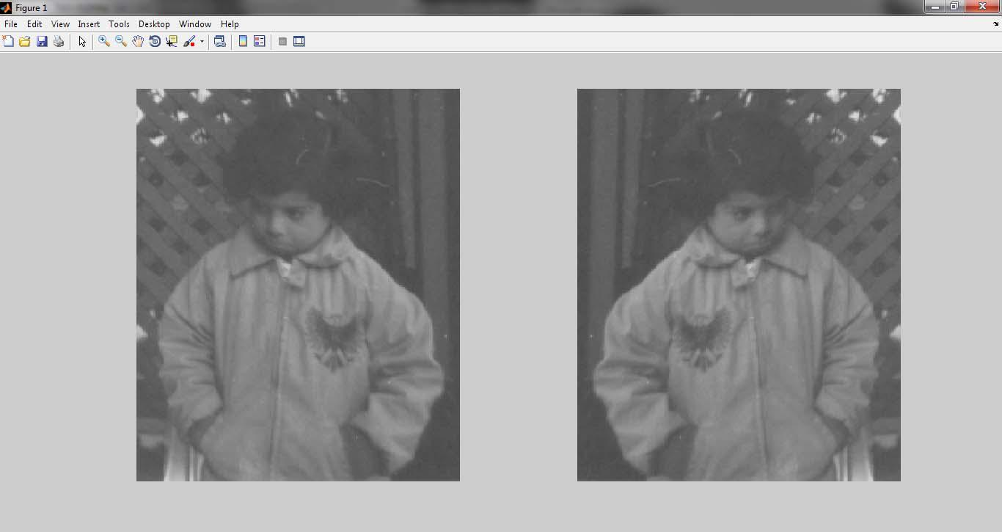

**Source Image and Resultant Image**

**Practice Tasks:**

**TASK 1**

Write a MATLAB code that reads a gray scale image and generates the flipped image of original image. Your output should be like the one given below-

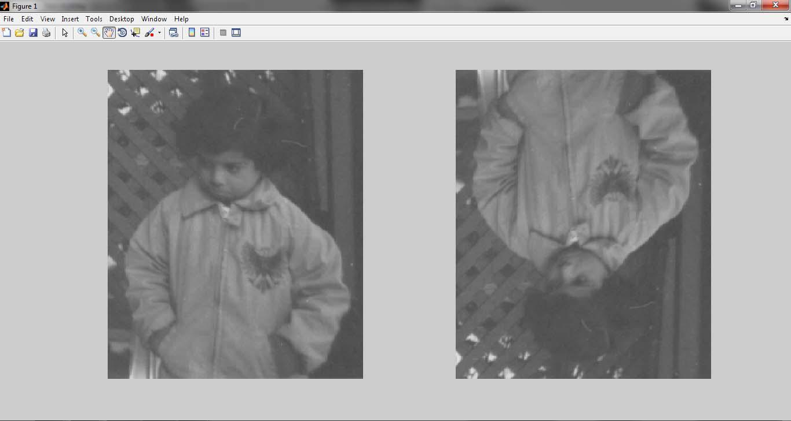

**Source Image with Desired Output**

**TASK 2**

Write a MATLAB code that will do the following

1. Read any gray scale image.
2. Display that image.
3. Again display the image such that the pixels having intensity values below than 50 will display as black and pixels having intensity values above than 150 will display as white. And the pixels between these will display as it is.

**TASK 3**

Write the syntax and purpose of use of some MATLAB standard functions-

1. imtool
2. who/whos
3. imfinfo
4. imcomplement
5. flip